***Screenshots of E-Circuits of Logic Gates formed using Boolean Expression.***

*1. y (A, B, C, D) = (0, 0, 0, 0).*

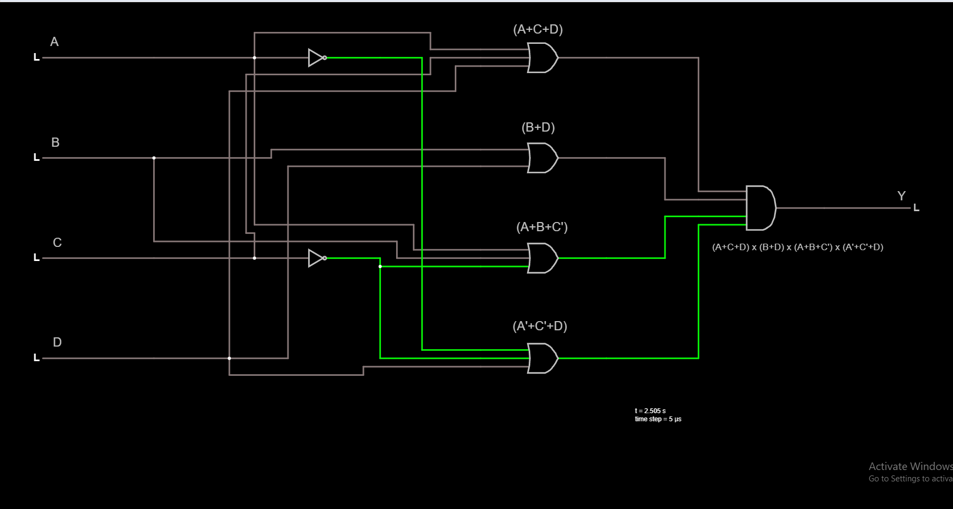

*2. y (A, B, C, D) = (0, 1, 0, 0).*

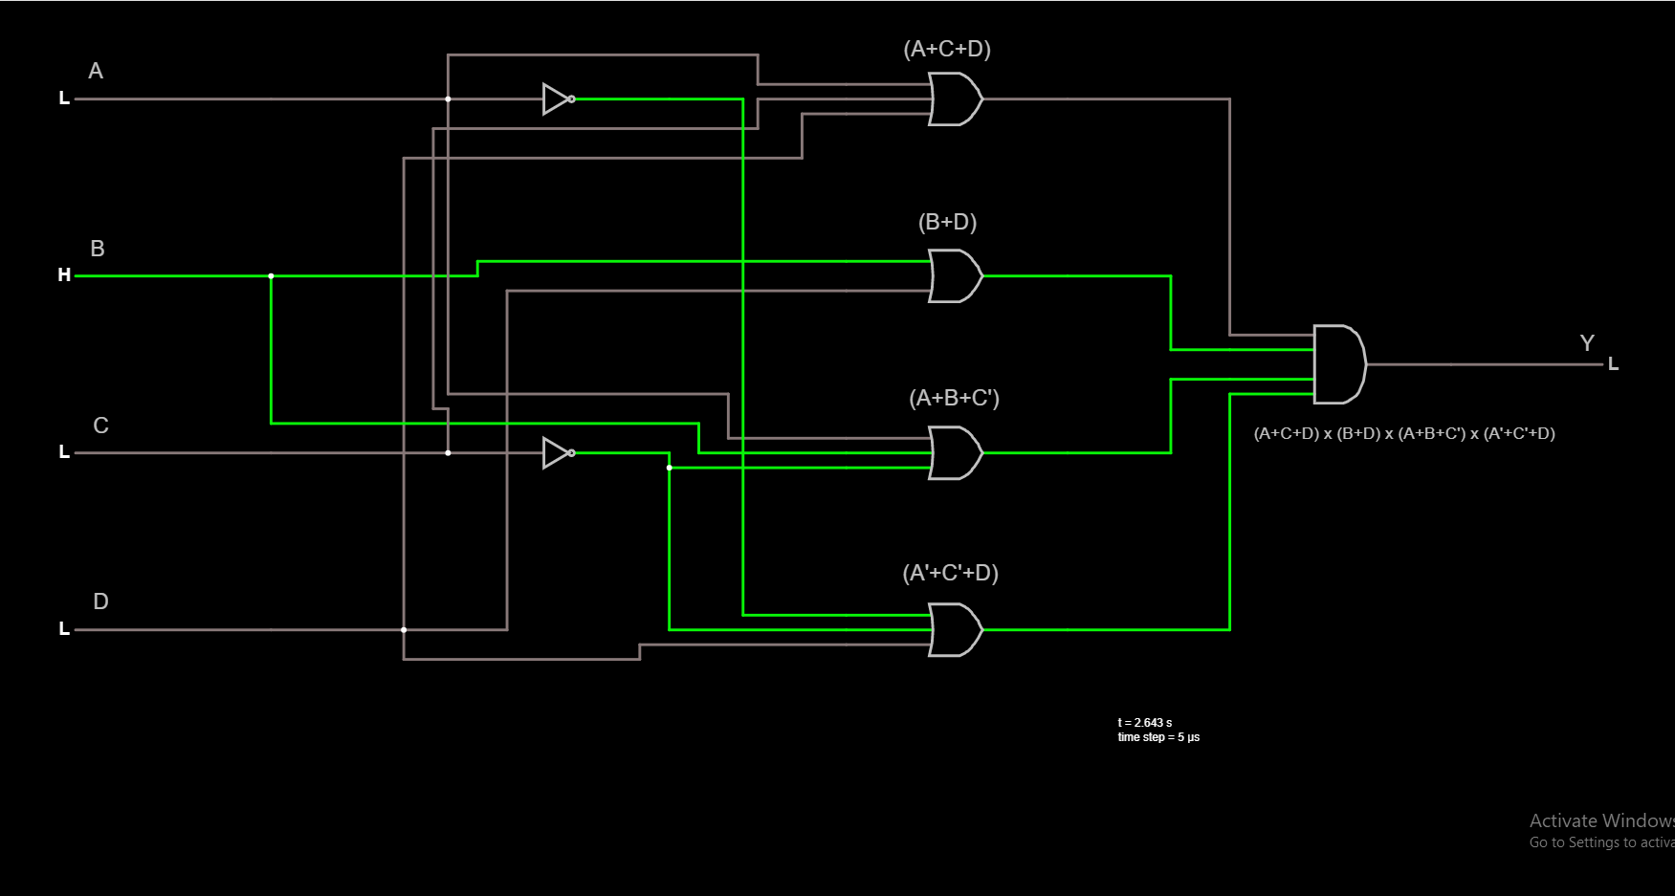

*3. y (A, B, C, D) = (1, 0, 0, 0).*

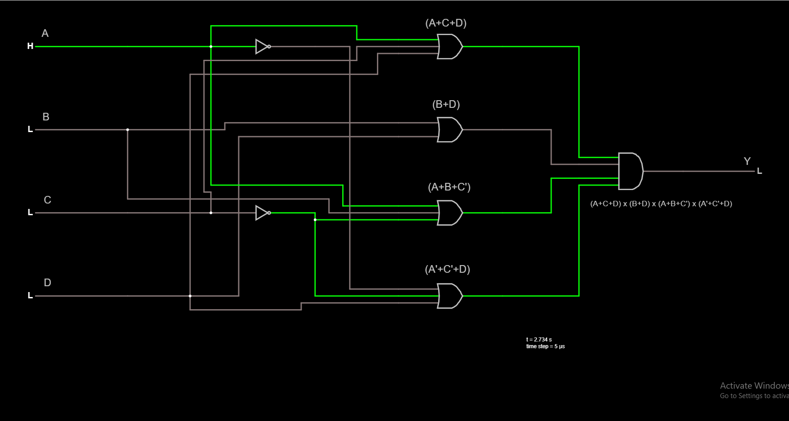

*4. y (A, B, C, D) = (1, 1, 0, 0).*

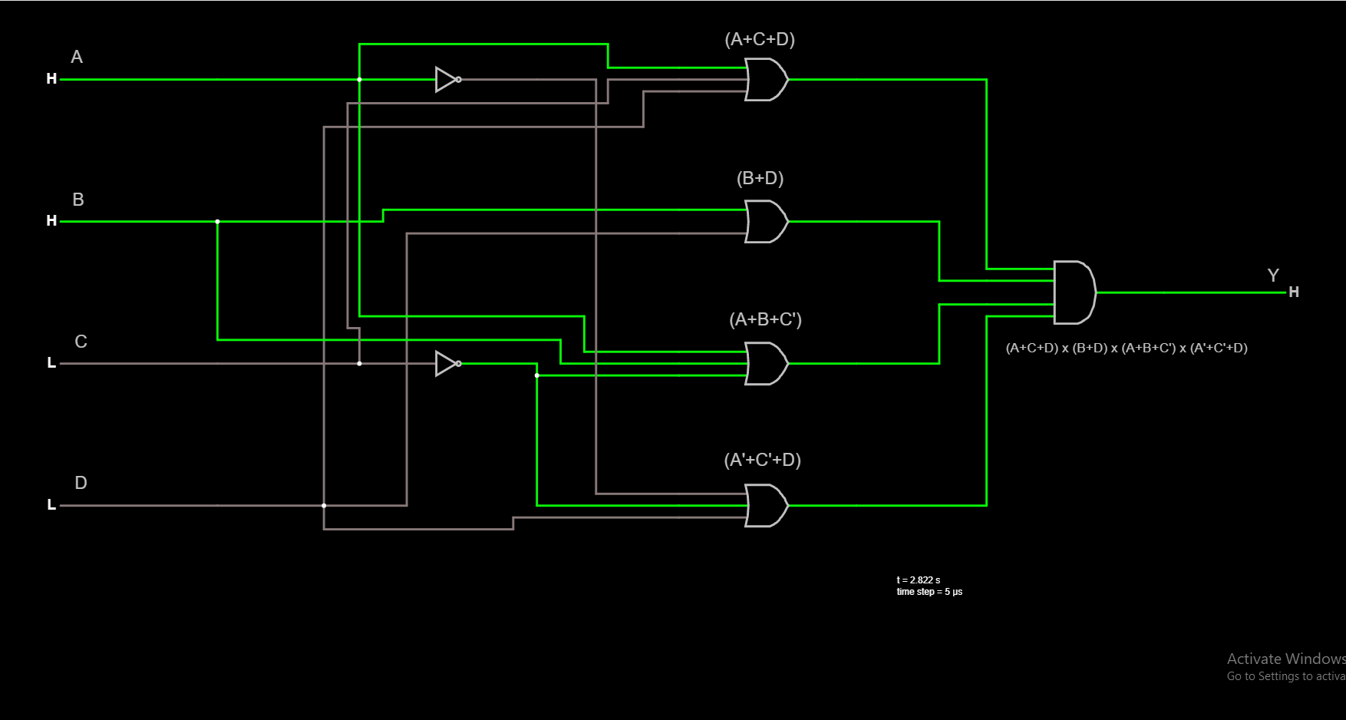

*5. y (A, B, C, D) = (1, 1, 1, 1).*

